Case 1:

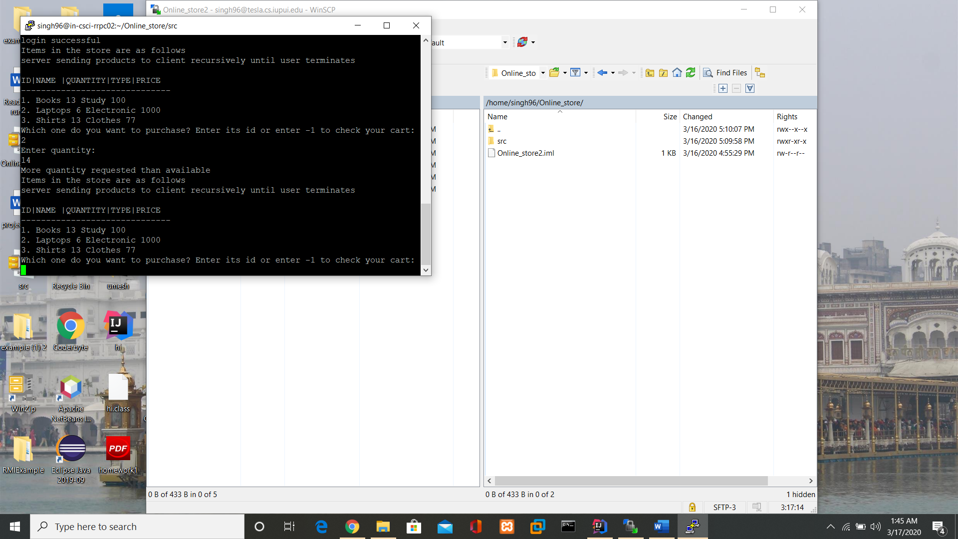

When more quantity ordered than available then exception is thrown that **“More quantity requested than available “.**